 [Translated from French to English - www.onlinedoctranslator.com](https://www.onlinedoctranslator.com/en/?utm_source=onlinedoctranslator&utm_medium=docx&utm_campaign=attribution)

Robzyl V5.2 Manual

Firmware for Quansheng UV-K5 radio

# Introduction

This firmware, a fork of NTOIVOLA's NUNU, is characterized by its multiple reception functions implementing the spectrum analyzer capable of processing up to 160 channels per second.

Links to the various resources are available at the end of the document (GitHub, Youtube, Telegram, etc.).

# Warnings and Responsibilities

**The radio sector is regulated; everyone is responsible for their use of their radio.**

# What's New in V5.2

* Switch to single VFO (space saving and interface simplification)
* Spectrum: New squelch management, addition of new screen without histogram, new PTT, FStart/Stop, Step, ListenBw and Modulation menus).
* Spectrum: Frequency history to be rethought following work on the squelch.
* New Roger Bips😊

# User Guide

* **Firmware Installation:**
* Download the latest version on GitHub (link at the end of the doc).
* Obtain the USB programming cable compatible with the station.
* Connect the radio to the computer then start the K5 while pressing the PTT button
* Then, with the LED on, transfer the firmware to the K5 via the online Flasher or K5prog-win (link at the end of the document).
* If you are going to replace the factory firmware, it is recommended to first backup your configuration and calibration using K5prog (see for example the F5SVP video)
* **Quick start:**
* Hidden menus: rarely used menus have been hidden for simplicity. To display the full menu, simply start the radio by pressing PTT + SIDE KEY 1
* Programming with Chirp: the driver to use to communicate with the Robzyl station is to be downloaded (link at the end of the doc). Be careful not to be in spectrum mode to be able to communicate with the PC.
* Last State Restore: After shutting down the K5, restarting it resumes in the mode active when it was shut down, taking into account your last saved spectrum settings.
* The main features of Robzyl firmware are described in the rest of this document. For basic K5 functions, please refer to its documentation.
* **VFO and Memory modes:**

These modes can be accessed alternately by long pressing key 3.

VFO mode

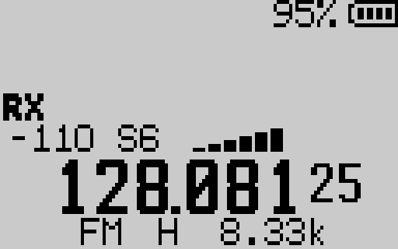

The single VFO mode allows you to freely enter a frequency. The M key menu gives access to all the parameters for step, modulation, etc.

Memory Mode

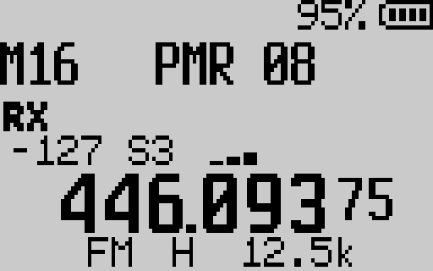

This other mode allows you to navigate through the K5's bank of 200 named memories. This bank must be prepared and injected into the K5 from Chirp.

* **Spectrum mode:**

Common features of Spectrum mode:

Main screen:

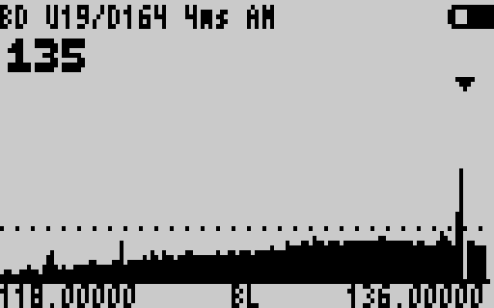

**LINE 1:**

**LINE 2:**

**BODY :**

**LINE 3:**

* Line 1:
* Spectrum Type: SL (Scan Lists), FR (Frequency Range), BD (Bands)
* Parameters of the squelch trigger UP Uxxx (trigger value on rising signal), and trigger Down Dxxx (invalidation value of a falling signal expl)
* Delay in capturing RSSI from a signal of 0 to 12 ms. Allows for faster scanning speed, but reduces signal-to-noise ratio.
* FM/AM/USB current modulation
* Line 2: Current frequency and CTCSS/DCS. Display may vary depending on the type of spectrum selected.
* Body: Graphical and dynamic representation of the analyzed channels and their signal level.
* Line 3: Current extensions and additional information: BL (a blacklist of frequencies is in progress).

The settings menu:

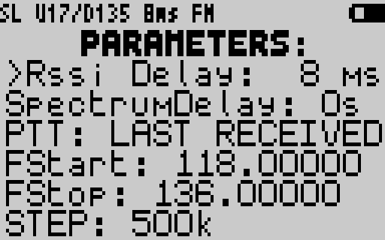

* RSSI Delay: RSSI capture time in ms. Too low a value may cause signals to be missed.
* SpectrumDelay: Sets the delay time for a signal to be monitored and fall below the squelch. If the value is infinite: press the Exit key to exit the monitoring screen.
* PTT (PTT option): LAST RECEIVED = last frequency heard, LAST VFO FREQ = VFO frequency, NINJA MODE: Experimental communication mode by frequency hopping at each PTT between 2 K5s using the spectrum in Ninja mode on a common Scanlist. See video on YouTube.
* Fstart/Fstop: setting of high/low frequencies in FR mode.
* Step: setting the frequency channel in FR mode.
* ListenBW: setting the listening bandwidth.
* Modulation: FM/AM/USB

Spectrum in simplified view:

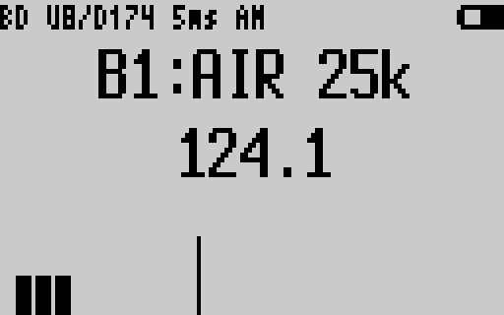

This screen provides a more synthetic view of the current scan while allowing easy adjustment of squelch parameters.

Frequency monitoring:

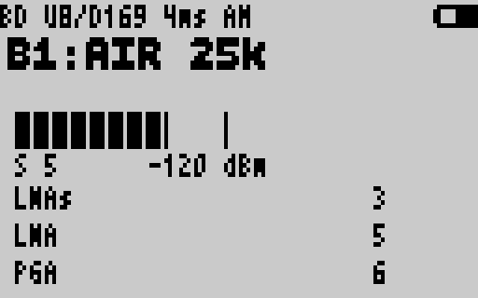

The monitor is launched on a frequency being listened to, either manually with the M key or under the effect of the SpectrumDelay.

The keys:

* Key 1: Skip a frequency to listen to
* Key 2: Switch to the simplified spectrum screen
* Key 5: Access Menu, then Up/Down to navigate, 1/3 to change values, 1/M to enter Fstart/Fstop.
* Key 7: Save the main settings
* M key: Switch to Monitoring on a frequency
* SIDE KEY 1: Blacklist a frequency to listen to it
* SIDE KEY 2: Disable D trigger auto-adjustment
* Key 3/9: Squelch adjustment parameter Uxxx
* */F key: Squelch setting parameter Dxxx (only if SIDE KEY 2 has been activated)

Advice :

* Squelch values ​​depend on your environment, antenna, and RSSI delay choice.
* RSSI Delay: 4-5 ms gives very good results.
* Trigger Up Uxxx: start at 10 and adjust until you no longer receive noise but rather modulation.
* Trigger Down Dxxx: must be positioned above the background noise
  + **Spectrum on ScanLists (SL mode):**
* Function: Allows you to load memories assigned to scanlists into the spectrum.
* Launch: From VFO/MR mode, press F+4
* Use and Advice:
* Previously the frequencies in memory must have been assigned to a scanlist (e.g. SL1 = PMR, SL2 = Repeaters, SL3 = Aero, etc.)
* On first use, go through each SL to adjust the U and possibly D squelch parameters, then memorize your values ​​with key 7
* Finally load your SLs into the spectrum via the selection menu in key 4.

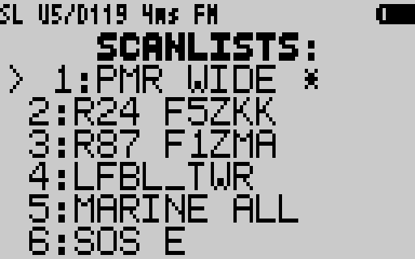

You navigate through this menu using the up/down keys.

Key 5: choose an SL excluding the others

Key 4: select/invalidate one or more SLs

* key: displays the memories assigned to the selected SL

The selected SLs appear with a * symbol. Then press Exit to launch the spectrum. Press 7 to save your configuration.

* + **Spectrum over Frequency range (FR mode):**
* Function: Allows you to analyze a frequency range from a central frequency or from a defined range
* Launch: From VFO/MR mode, press F+5
* Use and Advice:
* The frequency from the VOF/MR is brought to the spectrum as the center frequency. You can then adjust the settings of your spectrum according to your needs in step, modulation, etc. Settings key 5.
* The low/high frequency range can be adjusted in the menu via the FStart/FStop parameters. On these parameters, press 1 to access the entry and M to validate (* key for the comma).
* Adjust your squelch.
  + **Spectrum on Predefined Bands (BD mode):**
* Function: Allows spectrum analysis of predefined bands (e.g. PMR, CB, AERO, HAM, etc.).
* Launch: From VFO/MR mode, press F+6
* Use and Advice:
  + - The bands are stored in a customizable bands.h file with firmware recompilation (procedure linked at the end of the doc).
    - It is possible to set 32 ​​bands.

Example configuration file:

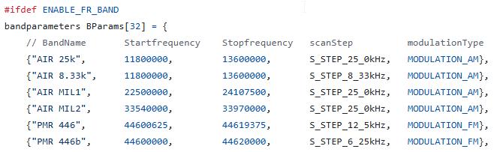

In the same way as in SL mode, the first time you use it, you are asked to set the squelch values ​​on the bands you are interested in. Up/down keys to navigate through the bands.

Then the key 4 menu allows you to choose the bands to analyze in the same way as the menu in SL mode:

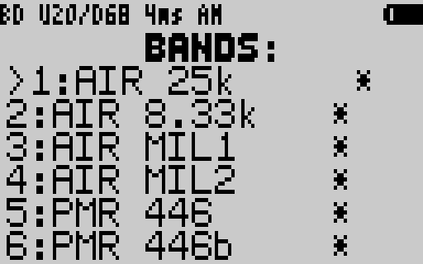

# FAQ

* Is it possible to lock your K5 in PMR band only?

Yes: Display hidden menus, menu No. 48, value PMR446 ONLY.

* Is the firmware compatible with SI4732 mods?:

No, but it might be possible.

* Is the firmware compatible with EEPROM mods?

No, but it is a possible evolution.

# Resources and useful links

Youtube:<https://www.youtube.com/@robby_69400>.

Github with Chrome flasher:<https://github.com/Robby69400/UV-K5-Firmware-Robby69>

Telegram Robzyl Dev:<https://t.me/k5robby69>

Driver chirp:<https://github.com/Robby69400/UV-K5-Firmware-Robby69/blob/master/Chirp/uvk5_Robby69.py>

Recompilation procedure:[https://github.com/Robby69400/UV-K5-Firmware-Robby69?tab=readme-ov-file#method-of-compilation-with-github-codespace-to-customize-scan-bands](https://github.com/Robby69400/UV-K5-Firmware-Robby69?tab=readme-ov-file#méthode-de-compilation-avec-github-codespace-pour-personaliser-les-scan-bands)